

National Textile University
Department of Computer Science

Subject:

Mobile Application Development

Submitted to:

Sir Rehan Sarwar

Submitted by:

Eemaan Fatima

Reg. number:

23-NTU-CS-FL-1146

Semester:
6th - A

Lab 02 :
Q1:

Task 1: The "Safe" Container Objective: Understand the Box Model and SafeArea implementation.
• Instruction: Create a new Flutter project and generate a StatelessWidget using the stless shortcut.
• Requirements:
o Set the Scaffold background color to Colors.blueGrey.
o Wrap the body of your Scaffold in a SafeArea widget.
o Inside the SafeArea, create a Container with a width and height of 250.
o Apply a margin of 25 pixels on all sides using EdgeInsets.all(25.0).
o Apply a padding of 15 pixels to the top and bottom using EdgeInsets.symmetric.

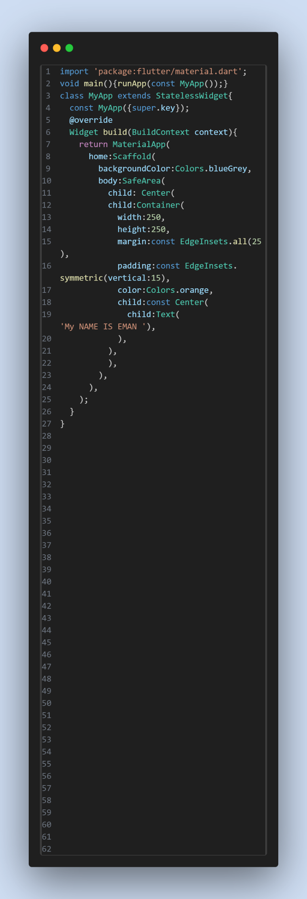

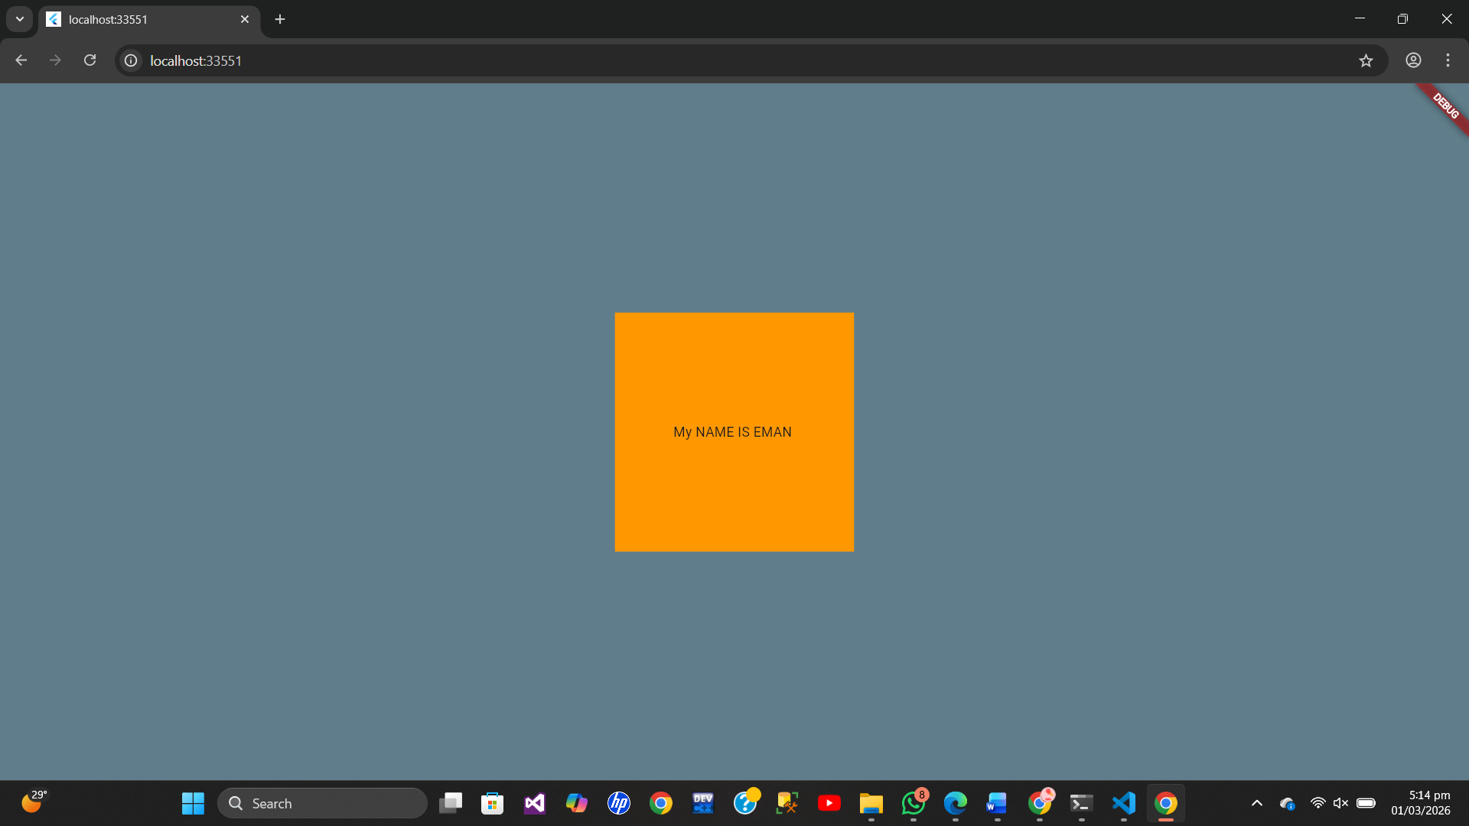

Q 2:

Task 2: Mastering the Vertical Axis Objective: Practice Column alignment and manual spacing.
• Requirements: o Create a Column as the primary child of your UI.
o Place three icons inside: Icons.favorite, Icons.thumb_up, and Icons.share.
o Use MainAxisAlignment.spaceEvenly to distribute the icons vertically.
o Wrap the Column in a Container with width: double.infinity.
o Set CrossAxisAlignment.end to push the icons to the right edge of the screen.

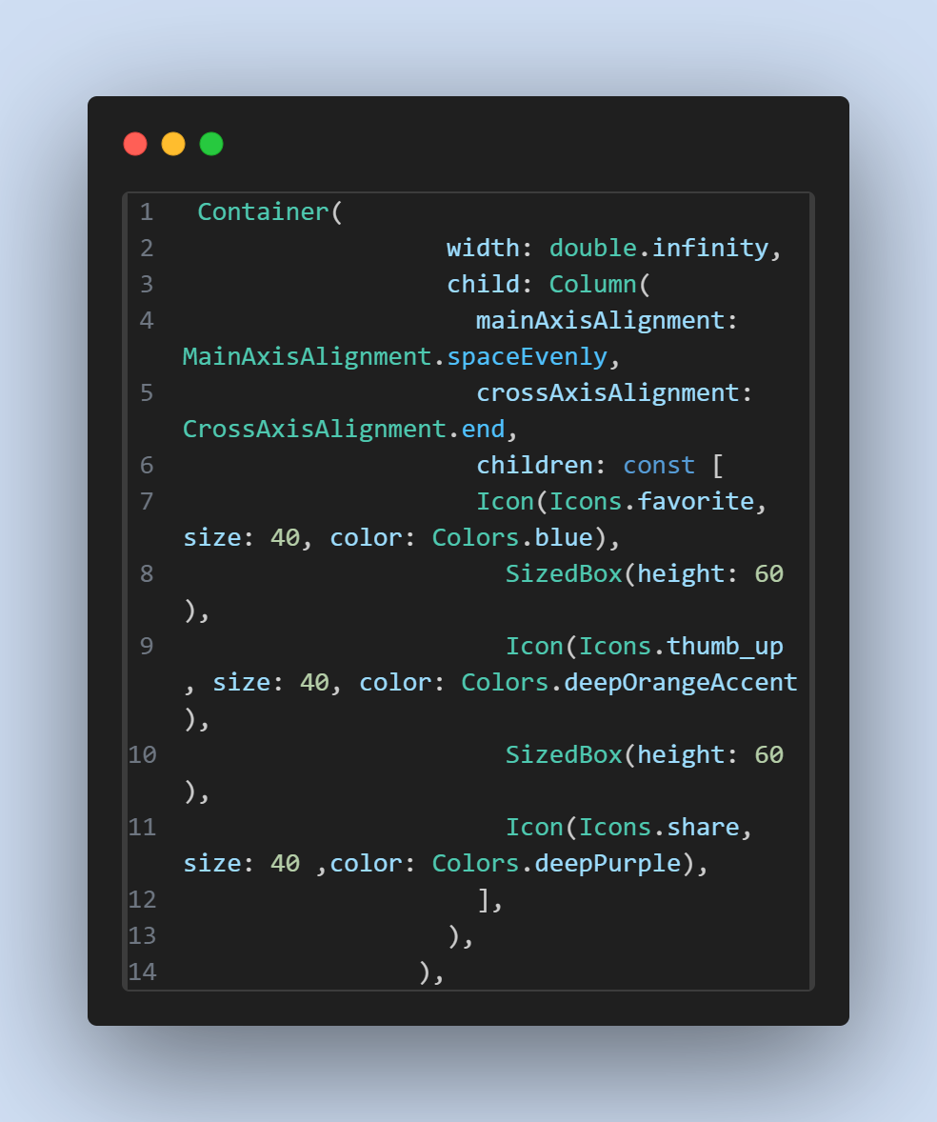
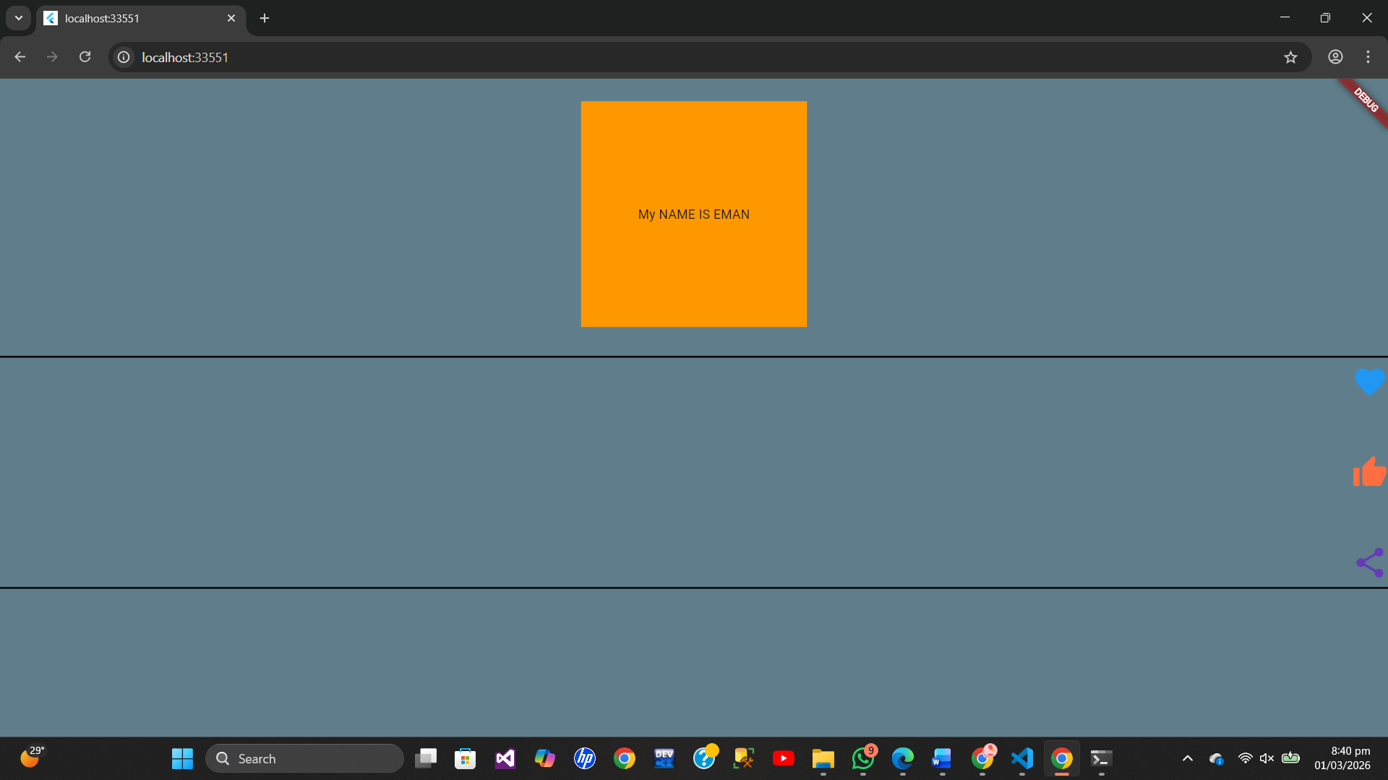

Q 3 :

Task 3: Horizontal Flow & Axis Flipping Objective: Contrast Row behavior with Column behavior.
• Requirements: o Create a Row widget.
o Add three icons: Icons.volume_up, Icons.bluetooth, and Icons.wifi.
o Set the MainAxisAlignment to center.
o Experiment with CrossAxisAlignment.stretch and observe how it affects the height of the row components.

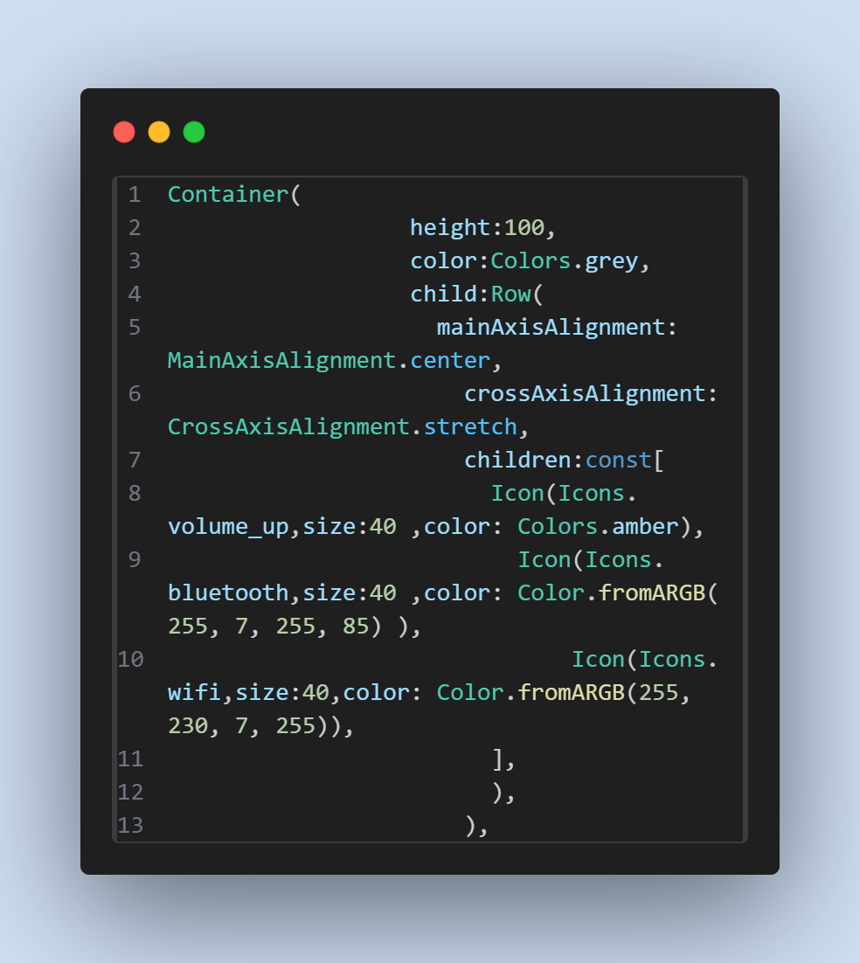
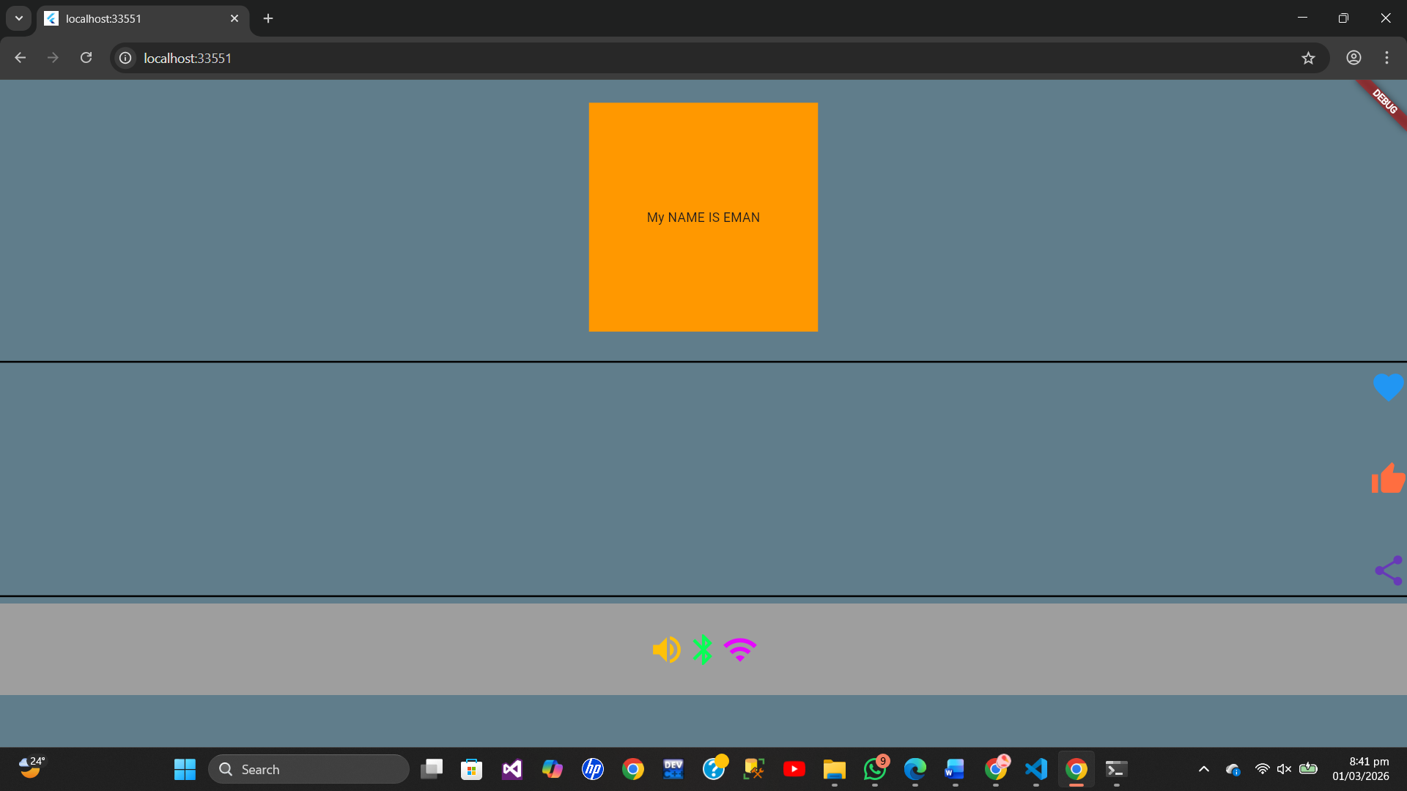

Q 4:

Task 4: The Final Alignment Challenge Objective: Nest Rows and Columns to create a manual "Status Panel."
• Requirements:
o Parent: A Column set to MainAxisAlignment.start.
o Child 1: A blue Container (Header) with a height of 100 and width of double.infinity.
o Child 2: A Row containing two smaller Containers (Red and Green) representing action buttons.
o Alignment Goal: Use MainAxisAlignment.spaceBetween on the Row to push the Red box to the far left and the Green box to the far right.
o Spacing: Use a SizedBox to ensure exactly 20 pixels of vertical space between the blue Header and the Button Row.
